13th SUNDAY IN ORDINARY TIME
GATHER IN GOD’S NAME
(*=please stand if you are able)

Prelude (A time for Silence and Reflection)

Welcome Rev. Jeniffer Rodriguez

*Call to Worship (Liturgy from Nancy C. Townley)
L: Welcome to worship today!
P: Thanks. We are glad to be here.
L: Even when things get hectic, always know that you will find welcome here.
P: We are grateful for the hospitality and friendship that are offered here.
L: Come, let us worship the God who always welcomes us.
P: Let us open our hearts to Christ who welcomed friend and stranger alike. AMEN.

*Praise God in Song
*Praise Song (See insert for lyrics) “I Have Decided to Follow Jesus"
*Praise Song (See insert for lyrics) “I Love You Lord”

Call to Confession
Friends in Christ, God invites us to hold the needs of our sisters and brothers as dear to us as our own needs. Loving our neighbors as ourselves, Together let us confess our sins:

Prayer of Confession (Nancy C. Townley)
P: Patient Lord, we want to extend the hand of welcome and friendship to all whom we meet, but you know that sometimes we shy away from reaching out. We make judgments about others based on their appearance and other surface factors, and we neglect your mandate to be a welcoming presence. That lack of welcome extends further when we see needs that must be addressed and choose to turn our backs. We turn away from the pain and suffering, protecting our own lives. Yet you remind us that as we welcome others, so we are also welcoming you. Heal us and give us strength and courage to always be welcoming others in your name. AMEN.

Silent Confession

Assurance of Pardon (Nancy C. Townley)
L: How wonderful it is to be welcomed by our Lord through God’s church. Rejoice in God’s welcoming love for you.
P: Thanks be to God! AMEN.

*Gloria Patri “Glory to God”
Glory to God, glory to God, glory in the highest!
Glory to God, glory to God, glory in the highest!
To God be glory forever! To God be glory forever!
Alleluia, Amen! Alleluia, Amen! Alleluia, Amen! Alleluia, Amen! Alleluia, Amen!
Glory to God, glory to God, glory to Christ Jesus!

Glory to God, glory to God, glory to Christ Jesus!
Glory to God, glory to God, glory to Christ Jesus!
To God be glory forever! To God be glory forever!
Alleluia, Amen! Alleluia, Amen! Alleluia, Amen! Alleluia, Amen! Alleluia, Amen!

Glory to God, glory to God, glory to the Spirit!
Glory to God, glory to God, glory to the Spirit!
To God be Glory Forever! To God be glory forever!
Alleluia, Amen! Alleluia, Amen! Alleluia, Amen! Alleluia, Amen! Alleluia, Amen!

Gloria a Dios, gloria a Dios, gloria en los cielos!
Gloria a Dios, gloria a Dios, gloria en los cielos!
A Dios la Gloria por Siempre! A Dios la Gloria por Siempre!
Aleluya , Amén, Aleluya, Amén,Aleluya , Amén, Aleluya, Amén, Aleluya, Amén

Gloria a Dios, gloria a Dios, gloria a Jesucristo!
Gloria a Dios, gloria a Dios, gloria a Jesucristo!
A Dios la Gloria por siempre! A Dios la Gloria por siempre!
Aleluya , Amén, Aleluya, Amén,Aleluya , Amén, Aleluya, Amén, Aleluya, Amén

Gloria a Dios, gloria a Dios, gloria al Espíritu!
Gloria a Dios, gloria a Dios, gloria al Espíritu!
A Dios la Gloria por Siempre! A Dios la Gloria por Siempre!
Aleluya , Amén, Aleluya, Amén,Aleluya , Amén, Aleluya, Amén, Aleluya, Amén

Prayer for Illumination (Revised Common Lectionary)
Through dreams and visions, O God, you broaden the horizon and hope of your people, that they may discover the meaning of your covenant, even in the midst of trial and exile. Increase the number of those who believe in your word so that all people may joyfully respond to your call and share in your promises. Amen

First Reading Genesis 22:1-14
After these events, God tested Abraham and said to him, “Abraham!” Abraham answered, “I’m here.” God said, “Take your son, your only son whom you love, Isaac, and go to the land of Moriah. Offer him up as an entirely burned offering there on one of the mountains that I will show you.” Abraham got up early in the morning, harnessed his donkey, and took two of his young men with him, together with his son Isaac. He split the wood for the entirely burned offering, set out, and went to the place God had described to him. On the third day, Abraham looked up and saw the place at a distance. Abraham said to his servants, “Stay here with the donkey. The boy and I will walk up there, worship, and then come back to you.” Abraham took the wood for the entirely burned offering and laid it on his son Isaac. He took the fire and the knife in his hand, and the two of them walked on together. Isaac said to his father Abraham, “My father?” Abraham said, “I’m here, my son.” Isaac said, “Here is the fire and the wood, but where is the lamb for the entirely burned offering?” Abraham said, “The lamb for the entirely burned offering? God will see to it, my son.” The two of them walked on together. They arrived at the place God had described to him. Abraham built an altar there and arranged the wood on it. He tied up his son Isaac and laid him on the altar on top of the wood. Then Abraham stretched out his hand and took the knife to kill his son as a sacrifice. But the Lord’s messenger called out to Abraham from heaven, “Abraham? Abraham?” Abraham said, “I’m here.” The messenger said, “Don’t stretch out your hand against the young man, and don’t do anything to him. I now know that you revere God and didn’t hold back your son, your only son, from me.” Abraham looked up and saw a single ram caught by its horns in the dense underbrush. Abraham went over, took the ram, and offered it as an entirely burned offering instead of his son. Abraham named that place “the Lord sees.” That is the reason people today say, “On this mountain the Lord is seen.”
L: This is the word of God.
P: Thanks be to God.

Anthem

Second Reading Matthew 10:40-42 Rev. Jeniffer Rodriguez
“Those who receive you are also receiving me, and those who receive me are receiving the one who sent me. Those who receive a prophet as a prophet will receive a prophet’s reward. Those who receive a righteous person as a righteous person will receive a righteous person’s reward. I assure you that everybody who gives even a cup of cold water to these little ones because they are my disciples will certainly be rewarded.”
L: This is the word of the Lord.
P: Thanks be to God.

Sermon “The Lord will Provide” Rev. Jeniffer Rodríguez

*Hymn (See insert for lyrics) “Great Is Thy Faithfulness”

RESPOND IN GRACE
Offertory

*Doxology “Praise to God the Father (Da n'ase)”
Praise to God the Father; praise to God the Son; praise to God the Spirit:
praise to the Three-in-One. Sing praise, sing praise to the Lord on high.
Praise to God Almighty; praise to the Holy One.
Da n’ase! Da n’ase! Da Onyame ase! Da n’ase! Da n’ase! Da Onyame ase!
Efiase oye n’a n’adoe doe so. Da n’ase! Da n’ase! Da Onyame ase!

*Prayer of Dedication (Liturgy from Thom Shuman)
L: We are not blessed by God so we might hoard them for ourselves, but use them to welcome those who are looking for a community, to feed those who hunger for friendship, to serve those whom the world has cast aside. Here are our gifts, Holy God. We pray you will use them as well as us in the work of your kingdom. Amen.

Prayers of the People

*Lord’s Prayer

*Hymn (See insert for lyrics) “Standing on the Promises”

Announcements

Benediction
God is good! All the time!

All the Time! God is Good!

Do not ever be afraid to welcome others. Bring your welcoming, accepting spirit to all those whom you meet. May God go with you on your journey this week and all of your days.

*Sharing the Peace of Christ
L: The Peace of Christ be with you.
P: And also with you.

Postlude

SUNDAY, JUNE 28, 2020
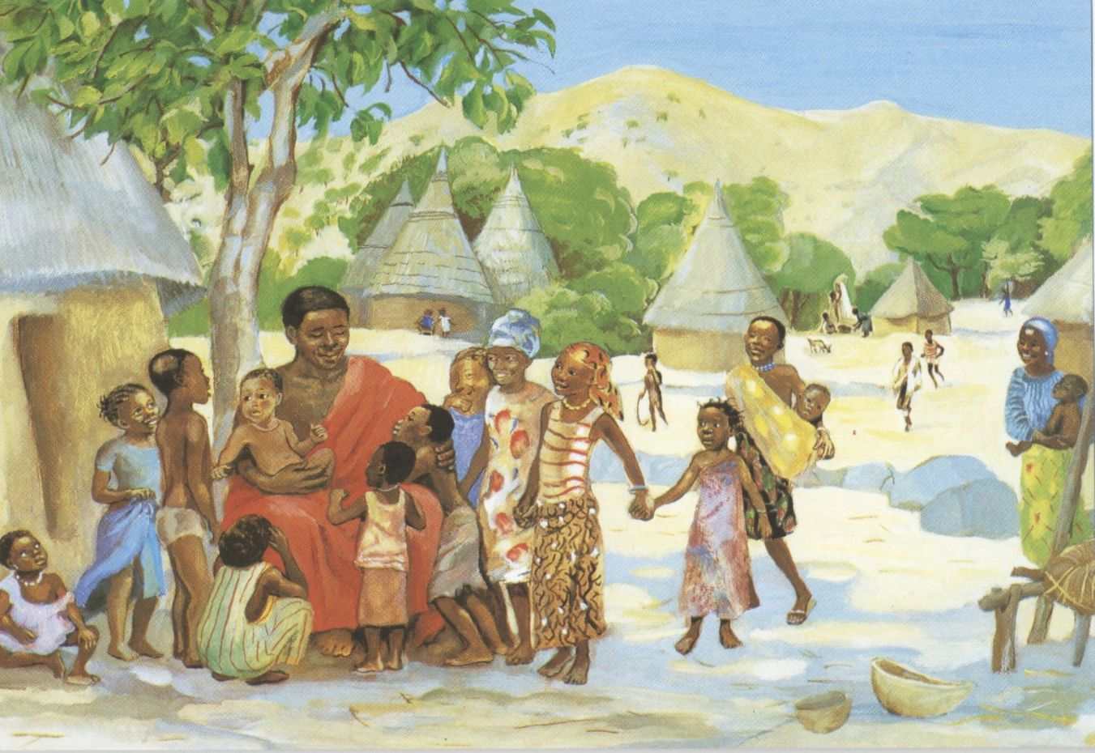
PASTOR
Rev. Jeniffer Rodriguez
Email: pastorjeniffer.ossining@gmail.com

MUSIC DIRECTOR
Carol Arrucci

ADMINISTRATIVE COORDINATOR
Lindsay Wilkens
Email: presoss@optonline.net

SEXTON
Robert Holmes

MINISTERS
All the Members

“A multicultural congregation worshipping together
where Jesus Christ is Lord; where men, women, and
children share in leadership; and where the strength
of our fellowship builds bridges to the community.”
First Presbyterian Church
34 South Highland Avenue
Ossining, NY 10562
Tel. (914) 941-0540
Email: presoss@optonline.net
Facebook: facebook.com/presoss
Website: www.fpcossining.org
EVENTS HAPPENING IN 2020

Bulletin Cover Image
Title: Jesus welcomes the children

JESUS MAFA is a response to the New Testament readings from the Lectionary by a Christian community in Cameroon, Africa. Each of the readings was selected and adapted to dramatic interpretation by the community members. Photographs of their interpretations were made, and these were then transcribed to paintings.

Date: 1973
Artist Jesus MAFA

Country Cameroon

-English Bible Study on Thursdays at 11:00AM via Zoom

-Spanish Bible Study on Tuesdays at 11:00 via Zoom

-Prayer Time on Fridays at 7:00PM via zoom

-Special Session meeting on Tuesday June 23, 2020 at 7:00PM

-Next Session meeting will be on Tuesday July 14, 2020 at 7:00PM via zoom

-Worship Team meeting, Wednesday July 15, 2020 at 9:39AM via zoom

-If you are incline in writing a prayer, song, poem or reflection, do not hesitate share it with us as community. Please send them to pastorjeniffer.ossining@gmail.com

Please join our Worship service on Sundays at 11am via zoom. Below is the information on how to join.

By Computer/Por Computadora
Join Zoom Meeting
https://us02web.zoom.us/j/870270865

Meeting ID: 870 270 865
One tap mobile
+16465588656,,870270865# US (New York)
+13126266799,,870270865# US (Chicago)

By Phone/Por teléfono
Dial by your location
+1 646 558 8656 US (New York)
+1 312 626 6799 US (Chicago)
+1 301 715 8592 US (Germantown)
+1 669 900 9128 US (San Jose)
+1 253 215 8782 US (Tacoma)
+1 346 248 7799 US (Houston)
Meeting ID: 870 270 865
Find your local number: https://us02web.zoom.us/u/kb17858bXg

Prayers and Praise

Please pray for Keeping Community Safe
Please pray for Food Banks
Please pray for Open Doors
Please pray for Everyone in leadership
Please pray for Children/ families
Please pray for Bus drivers
Please pray for Expecting mothers
Please pray for The Appiah-Twumassi's family
Please pray for The Clemmens family
Please pray for The Boateng Family
Please pray for The Otu's family
Please pray for The Supina/Ruess family
Please pray for The Pinto's family
Please pray for The Ellison's family
Please pray for The Gilchrest's family
Please pray for The Sevilla's family
Please pray for The Swartout's family
Please pray for Clare
Please pray for The White House
Please pray for For the ones who risk their lives to save others.
Please pray for For wisdom. For patience
Please pray for Essential workers
Please pray for Susan Carretta

PRAISE SONGS AND HYMNS:

I Have Decided to Follow Jesus
1. I have decided to follow Jesus, I have decided to follow Jesus,
I have decided to follow Jesus - no turning back, no turning back.

2. The world behind me, the cross before me, the world behind me, the cross before me,
the world behind me, the cross before me - no turning back, no turning back.

3. Though none go with me, still I will follow, though none go with me, still I will follow,
though none go with me, still I will follow— no turning back, no turning back.

I Love You, Lord
I love you, Lord, and I lift my voice to worship you;
O my soul, rejoice. Take joy, King, in what you hear;
May it be a sweet, sweet sound in your ear.

Great Is Thy Faithfulness
1. Great is thy faithfulness, O God my Father;
there is no shadow of turning with thee.
thou changest not, thy compassions they fail not.
As thou hast been thou forever wilt be.
Refrain:
Great is thy faithfulness!
Great is thy faithfulness!
Morning by morning new mercies I see.
All I have needed thy hand hath provided.
Great is thy faithfulness, Lord unto me!
2. Summer and winter, and springtime and harvest,
sun, moon, and stars in their courses above
join with all nature in manifold witness
to thy great faithfulness, mercy, and love. [Refrain]
3. Pardon for sin and a peace that endureth,
thine own dear presence to cheer and to guide,
strength for today and bright hope for tomorrow,
blessings all mine, with ten thousand beside! [Refrain]

Standing on the Promises
1. Standing on the promises of Christ my king,
through eternal ages let his praises ring;
glory in the highest, I will shout and sing,
standing on the promises of God.

Refrain:
Standing, standing,
standing on the promises of God my Savior;
standing, standing,
I’m standing on the promises of God.

2. Standing on the promises that cannot fail,
when the howling storms of doubt and fear assail,
by the living Word of God I shall prevail,
standing on the promises of God. [Refrain]

3. Standing on the promises of Christ the Lord,
bound to him eternally by love’s strong cord,
overcoming daily with the Spirit’s sword,
standing on the promises of God. [Refrain]

4. Standing on the promises I cannot fall,
listening every moment to the Spirit’s call,
resting in my Savior as my all in all,
standing on the promises of God. [Refrain]

